Case Study 4

Ray Jones
rjones16@mail.niagara.edu
Computer Forensics – CIS 285B
Instructor: Dr. Glenn Papp
12/02/2024

Introduction:

The goal of Case Study Four is to examine the image file ‘DellLatitudeImage.E01,’ which is an image of a Dell Latitude laptop that was found abandoned. It is suspected that Greg Schardt, also known as Mr. Evil, used this laptop for hacking purposes by parking his vehicle near wireless access points, using an antenna to steal credit card numbers, wireless passwords and intercept internet traffic. Using programs such as FTK, FTK Imager, and Autopsy, the objective is to perform forensic analysis to find evidence of hacking software and their use, along with any other data that may tie the computer to the suspect.

Question 1:
What is the image hash? Does the acquisition and verification hash match?
- Yes, the acquisition and verification hashes both match, this signifies that the image file was not tampered with during the imaging process. Matching hashes confirm that the images is an exact copy of the original data.
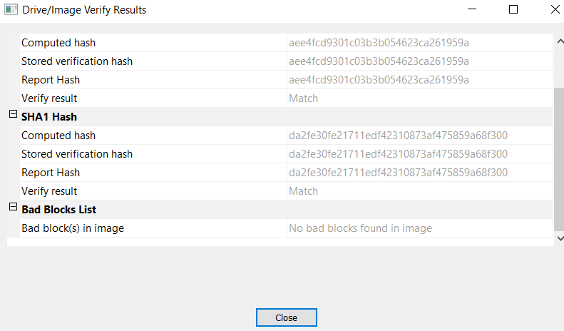
Question 2:
What operating system was used on the computer?
- According to the file system information in the properties tab within FTK, the file system for this image is Windows XP.
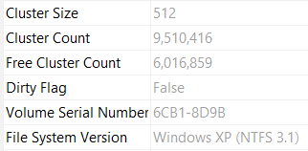
Question 3:
When was the install date?
- According to the software registry file, SOFTWARE\\Microsoft\\Windows NT\\CurrentVersion, the operating system was installed on Thursday, August 19th, 2004.
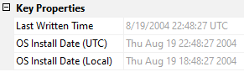
Question 4:
What is the timezone settings?
- According to the system registry file, SYSTEM\\ControlSet001\\Control\\TimeZoneInformation\\StandardName the time zone settings are set to Central Daylight Time.
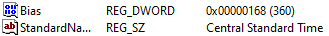
Question 5:
Who is the registered owner?
- According to the software registry file, SOFTWARE\\Microsoft\\Windows NT\\CurrentVersion, the Registered Owner is Greg Schardt.
Question 6:
What is the computer account name?
- According to the system registry file, SYSTEM\\ControlSet001\\Control\\ComputerName\\ComputerName, the computer account name is N-1A9ODN6ZXK4LQ.
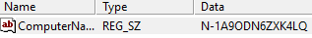
Question 7:
What is the primary domain name?
- According to the software registry file, SOFTWARE\\Microsoft\\Windows NT\\CurrentVersion\\Winlogon, this computer was not connected to a domain.
Question 8:
What was the last recorded computer shutdown date/time?
- According to the system registry file, SYSTEM\\ControlSet002\\Control\\Windows, the last shutdown is in binary, C4 92 8E 51 86 8B C4 01. By locating the system file in FTK Imager and searching for C4 92 8E 51 86 8B C4 01 within the system files hex values, using the hex interpreter, the actual date/time of the last shutdown is revealed, 8/26/2004 at 4:04pm (UTC) or 9:04am (MST/Denver).
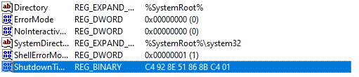
Question 9:
How many accounts are recorded (total number)?
- According to the SAM file, SAM\\Domains\\Users, you see a total of 5 user accounts listed. Administrator, Guest, HelpAssistant, Mr. Evil, and Support_388945a0.
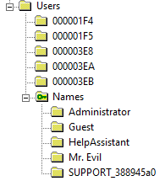
Question 10:
What is the account name of the user who mostly uses the computer?
- According to the SAM file, SAM\\Domains\\Users\\000003EB, username Mr. Evil is the only account with a logon count above zero, at 15.
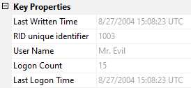
Question 11:
Who was the last user to logon to this computer?
- According to the SAM file, SAM\\Domains\\Users\\000003EB, Mr. Evil was the last user to logon to this computer, the other four users have never logged on. Mr. Evil last logged on 8/27/2004.
Question 12:
A search for the name of “Greg Schardt” reveals multiple hits. One of these proves that Greg Schardt is Mr. Evil and is also the administrator of this computer. What file is it? What software program does this file relate to?
- By doing an index search in FTK for the terms ‘Schardt’ and ‘Evil’, you’ll locate 12 files matching both names. The first file, ‘AppEvent.Evt’, you’ll see both the computer’s username: Mr. Evil and it’s registered owner: Greg Schardt, which ties them together as the same person. I also found references to both Mr. Evil and Greg Schardt in the ‘inrunin.ini’ file. Greg Schardt is listed as the ‘REGOWNER’ and Mr. Evil as ‘LANUSER’.
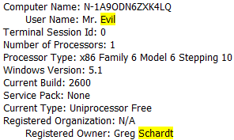
Question 13:
List the network cards used by this computer.
- According to the software registry file, SOFTWARE\\Microsoft\\Windows NT\\CurrentVersion\\NetworkCards\\2, the network cards used by this computer is a Xircom CardBus Ethernet 100 and Modem 56.
Question 14:
This same as in question 12 file reports the IP address and MAC address of the computer. What are they?
- In the same file as Question 12 where Mr. Evil is listed as the ‘LANUSER’, the LANIP is listed as 192.168.1.111 and the LANNIC (MAC Address) is listed as 0010a4933e09 (00:10:a4:93:3e:09).
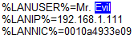
Question 15:
An internet search for vendor name/model of NIC cards by MAC address can be used to find out which network interface was used. In the above answer, the first 3 hex characters of the MAC address report the vendor of the card. Which NIC card was used during the installation and set-up for LOOK@LAN?
- According to dnschecker.org, the mac address prefix 00:10:a4 lists XIRCOM as the vendor/company for the NIC card. Xircom CardBus Ethernet 100 was used to install LOOK@LAN.
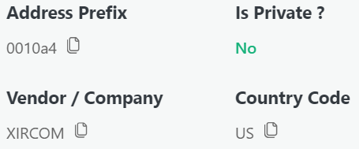
Question 16:
Find 6 installed programs that may be used for hacking.
- According to the registry file software[12652].tmp, you see many programs that may be used for hacking. These include Anonymizer Bar, Bogosoft Network Stumbler, Gemplus, Look@LAN, and GlobalSCAPE CuteFTP. In the program files, you may see hacking programs such as Cain, Ethereal and 123Wasp.
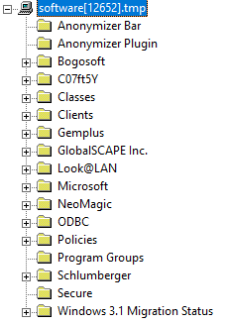
Question 17:
What is the SMTP email address for Mr. Evil?
- By running an index search for SMTP, I found a file called AGENT.INI, within the file, it shows ‘FullName’ as Mr. Evil and his SMTP email address listed as ‘whoknowsme@sbcglobal.net’. I also found this information a second time while searching for the NNTP.
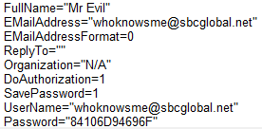
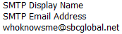
Question 18:
What are the NNTP (news server) settings for Mr. Evil?
- Mr. Evil uses Outlook Express ‘outnews’ as his news server client per the Outlook Newsreader registry files. Also, by doing an index search for NNTP, I found more specific information such as ‘news.dallas.sbcglobal.net’ as the NNTP Server along with credentials.
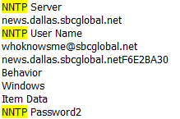
Question 19:
What two installed programs show this information?
- After running an index search for NNTP, a few program files were related to NNTP. Agent, Cain and Outlook Express.
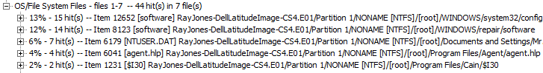
Question 20:
List 5 newsgroups that Mr. Evil has subscribed to?
- To find the newsgroups that Mr. Evil was subscribed too, I located Outlook Express in the Application Data folder within Documents and Settings to find files such as alt.2600.cardz.dbx, which are associated to newsgroups that Mr. Evil subscribes too. Others are alt.2600.codez.dbx, alt.2600.crackz.dbx, alt.2600.dbx, and alt.2600.hackerz.dbx.
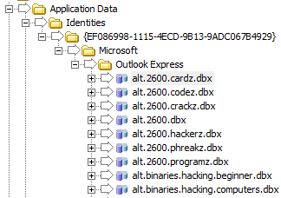
Question 21:
A popular IRC (Internet Relay Chat) program called MIRC was installed. What are the user settings that was shown when the user was online and in a chat channel? Hint, define what a .ini file is and how we can use them?
- According to the mirc.ini file, the user settings are, User: Mine Me, Email: none@of.ya, and anick: mrevilrulez.
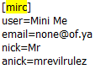
Question 22:
This IRC program has the capability to log chat sessions. List 3 IRC channels that the user of this computer accessed.
- After accessing the program files, mIRC, Logs, many IRC channels were uncovered. #Chataholics.UnderNet.log, #Cybercafe.UnderNet.log, #Elite.Hackers.UnderNet.log, #evilfork.EFnet.log, and #funny.UnderNet.log.
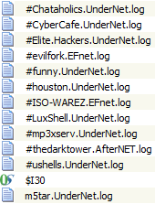
Question 23:
Ethereal, a popular “sniffing” program that can be used to intercept wired and wireless internet packets was also found to be installed. When TCP packets are collected and re-assembled, the default save directory is that users \My Documents directory. What is the name of the file that contains the intercepted data?
- Within the program files, Documents and Settings, Mr. Evil, Application Data, Ethereal you’ll find a file called ‘recent’. Within this file you’ll see the location of the default save directory for the reassembled packets. C:\Documents and Settings\Mr. Evil\interception.
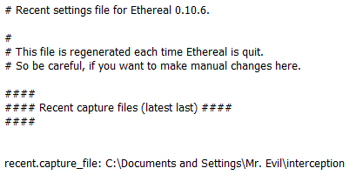
Q24:
Viewing the file in a text format reveals much information about who and what was intercepted. What type of wireless computer was the victim (person who had his internet surfing recorded) using?
- After running an index search for ‘interception’, a missing file was uncovered named interception. The wireless computer was a Windows CE (Pocket PC).
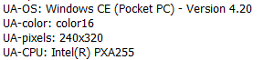
Q25:
What websites was the victim accessing?
- Within the same interception file, the websites listed are mobile.msn.com and MSN Hotmail.
Q26:
Search for the main users web-based email address. What is it?
- Mr. Evil’s Yahoo email account as mr.evilrulez@yahoo.com.
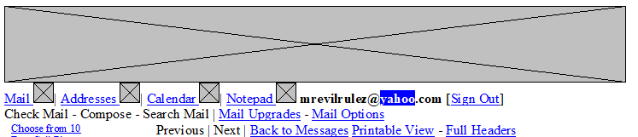
Q27:
Yahoo mail, a popular web-based email service, saves copies of the email under what file name?
- Mr. Evil’s Yahoo emails were found in the ShowLetter[1].htm file within Documents and Settings…Temporary Internet Files.
Question 28:
How many executable files are in the recycle bin?
- By searching RECYCLER, I found that this user has four .exe files in the recycling bin. Dc1.exe, Dc2.exe, Dc3.exe, and Dc4.exe.
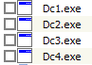
Question 29:
Are these files really deleted?
- No, files that are sent to the recycling bin are not yet deleted and can be easily restored.

Question 30:
How many files are actually reported to be deleted by the file system?
- By looking into the INFO2 file in the recycler, and it’s file content you will see five deleted files.
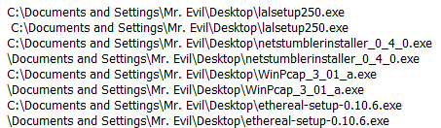

Conclusion:

In summary, after performing forensic analysis on the image of Mr. Evil’s Dell laptop, the evidence suggests that Greg Schardt, aka Mr. Evil and his associates were using the laptop to perform crimes. After performing an index search ,on the terms ‘Schardt’ and ‘Evil,’ multiple files were found connecting Greg Schardt to his alias, Mr. Evil determining that they are the same person. Many hacking programs were found installed on the PC such as Anonymizer Bar, Network Stumbler, Look@LAN, and CuteFTP which indicate that the laptop was indeed used for hacking purposes. Mr. Evil’s mIRC credentials were found in the mirc.ini file, which helped reveal that he was in multiple hacking related chat groups such as #Elite.Hackers. Mr. Evil was using Ethereal, a popular “sniffing” program to intercept wireless internet from his victims and store the stolen information on his PC. It’s easy to conclude that Mr. Evil and his associates have been hacking innocent victims based on the evidence uncovered on his PC.

